**🔍 Executive Summary**

This paper challenges conventional spread-based valuation (like Z-spread/OAS) for credit-risky bonds and instead advocates a **survival-based modeling** framework using **Fractional Recovery of Par (FRP)**. It introduces robust and consistent valuation, relative value, and risk measures that hold even in distressed markets — ideal for your context of computing clean PnL and Theta.

**🧱 Breakdown of Key Concepts**

**🧾 1. Problems with Conventional Spread Measures**

* **Conventional Valuation** assumes:

PV=∑CF(ti)⋅Z(ti)PV = \sum CF(t_i) \cdot Z(t_i)PV=∑CF(ti​)⋅Z(ti​)

where Z(ti)Z(t_i)Z(ti​) is a risky discount factor based on a “risky” yield curve (Z-spread above base curve).

* This **fails for credit-risky/distressed bonds** because:
  + Cash flows are *not fixed* (due to default risk).
  + Does *not account for recoveries* or *acceleration of debt*.
  + Z-spread term structures become **misleading**, especially during distress (e.g., downward sloping due to price trading "to recovery").

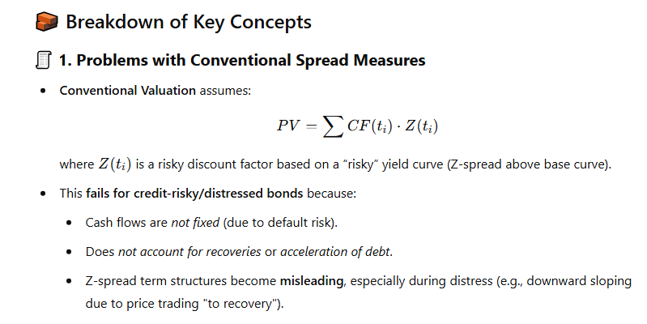

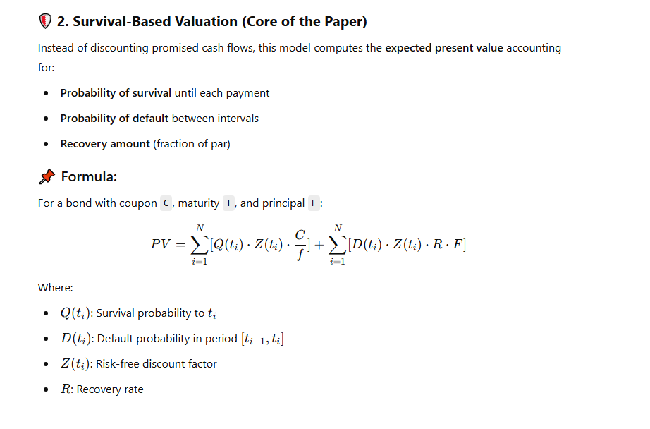

**🛡 2. Survival-Based Valuation (Core of the Paper)**

Instead of discounting promised cash flows, this model computes the **expected present value** accounting for:

* **Probability of survival** until each payment
* **Probability of default** between intervals
* **Recovery amount** (fraction of par)

**📌 Formula:**

For a bond with coupon C, maturity T, and principal F:

PV=∑i=1N[Q(ti)⋅Z(ti)⋅Cf]+∑i=1N[D(ti)⋅Z(ti)⋅R⋅F]PV = \sum_{i=1}^{N} [Q(t_i) \cdot Z(t_i) \cdot \frac{C}{f}] + \sum_{i=1}^{N} [D(t_i) \cdot Z(t_i) \cdot R \cdot F]PV=i=1∑N​[Q(ti​)⋅Z(ti​)⋅fC​]+i=1∑N​[D(ti​)⋅Z(ti​)⋅R⋅F]

Where:

* Q(ti)Q(t_i)Q(ti​): Survival probability to tit_iti​
* D(ti)D(t_i)D(ti​): Default probability in period [ti−1,ti][t_{i-1}, t_i][ti−1​,ti​]
* Z(ti)Z(t_i)Z(ti​): Risk-free discount factor
* RRR: Recovery rate

**⏳ Theta (Passage of Time PnL) Implications**

* In survival-based models, **theta arises from the time decay of both survival probabilities and discount factors**.
* Since prices reflect expected values of uncertain cash flows, **passage of time shortens the horizon** over which survival is measured → impacts both survival probabilities and discounting.

For distressed bonds:

* **Much of the value is from the recovery assumption**.
* As time passes, **less and less value changes** if default is imminent → **theta approaches zero**.
* For non-distressed names, theta is larger due to changing survival probabilities and time decay of risk-free discounting.

**🧪 Recovery Assumptions Compared**

| **Recovery Method** | **Meaning** | **Works for Distressed?** |
| --- | --- | --- |
| FRT (Treasury) | % of discounted future cashflows | ❌ |
| FRMV (Market Value) | % of pre-default price | ❌ |
| **FRP (Par)** | % of par (constant) | ✅ Best match with market behavior |
| ZR (Zero Recovery) | No value post-default | ✅ Only in worst-case |

They argue **FRP is most realistic**, especially for pricing CDS and distressed bonds.

**🧠 Estimating Survival Curves: Exponential Splines**

**Method:**

* Use exponential spline regression to fit a **survival probability curve** directly from observed bond prices.

**Advantages:**

* Flexible, robust
* Ensures decreasing survival probability
* Enforces positive hazard rate

**Used For:**

* Valuation
* Risk metrics (e.g., hazard rate, par spread)
* Constructing credit curves for pricing and comparison

**📏 Key Relative Value and Risk Measures**

| **Measure** | **Meaning** |
| --- | --- |
| **Hazard Rate (Forward ZZ Spread)** | Instantaneous default probability |
| **Par Spread (P-Spread)** | Spread over base curve that makes bond price at par |
| **BCDS (Bond-Implied CDS)** | Fair CDS spread implied by bond prices |
| **OAS-to-Fit (OASF)** | Bond-specific relative value vs fitted price |

**📌 Impact on Theta Calculation for Clean PnL**

To calculate **Theta** accurately:

* You must **reprice the same position using yesterday’s market and today’s valuation date**, using the **same survival probabilities and recovery assumptions**.
* In **distress**, value barely changes with time ⇒ **Theta ≈ 0**
* In **normal** or high-yield credit bonds, **Theta = -dPV/dt** comes from decay in:
  + Discounted future cash flows
  + Shorter horizon for survival probabilities

**✅ Final Takeaways for Amine**

1. Use **survival-based pricing with FRP** to calculate passage of time PnL (Theta) for credit-risky bonds.
2. **Theta is sensitive to shape of survival curve** — flatter or front-loaded hazard = smaller theta.
3. **In deep distress**, Theta approaches zero (price already reflects expected recovery).
4. **Use exponential splines** to derive survival curves for consistent Clean PnL calculation.
5. Avoid strippable cash flow models (Z-spread, OAS) — they distort theta, especially under default risk.

Let me know how you'd like to proceed next — I can help build a Python-based theta calculator using these formulas, or walk through a numerical example using one of your distressed bonds.

**You said:**

i would love that using python, also walk me through these numerical examples